The Inner Circle

2D Drawings- Engine Assembly

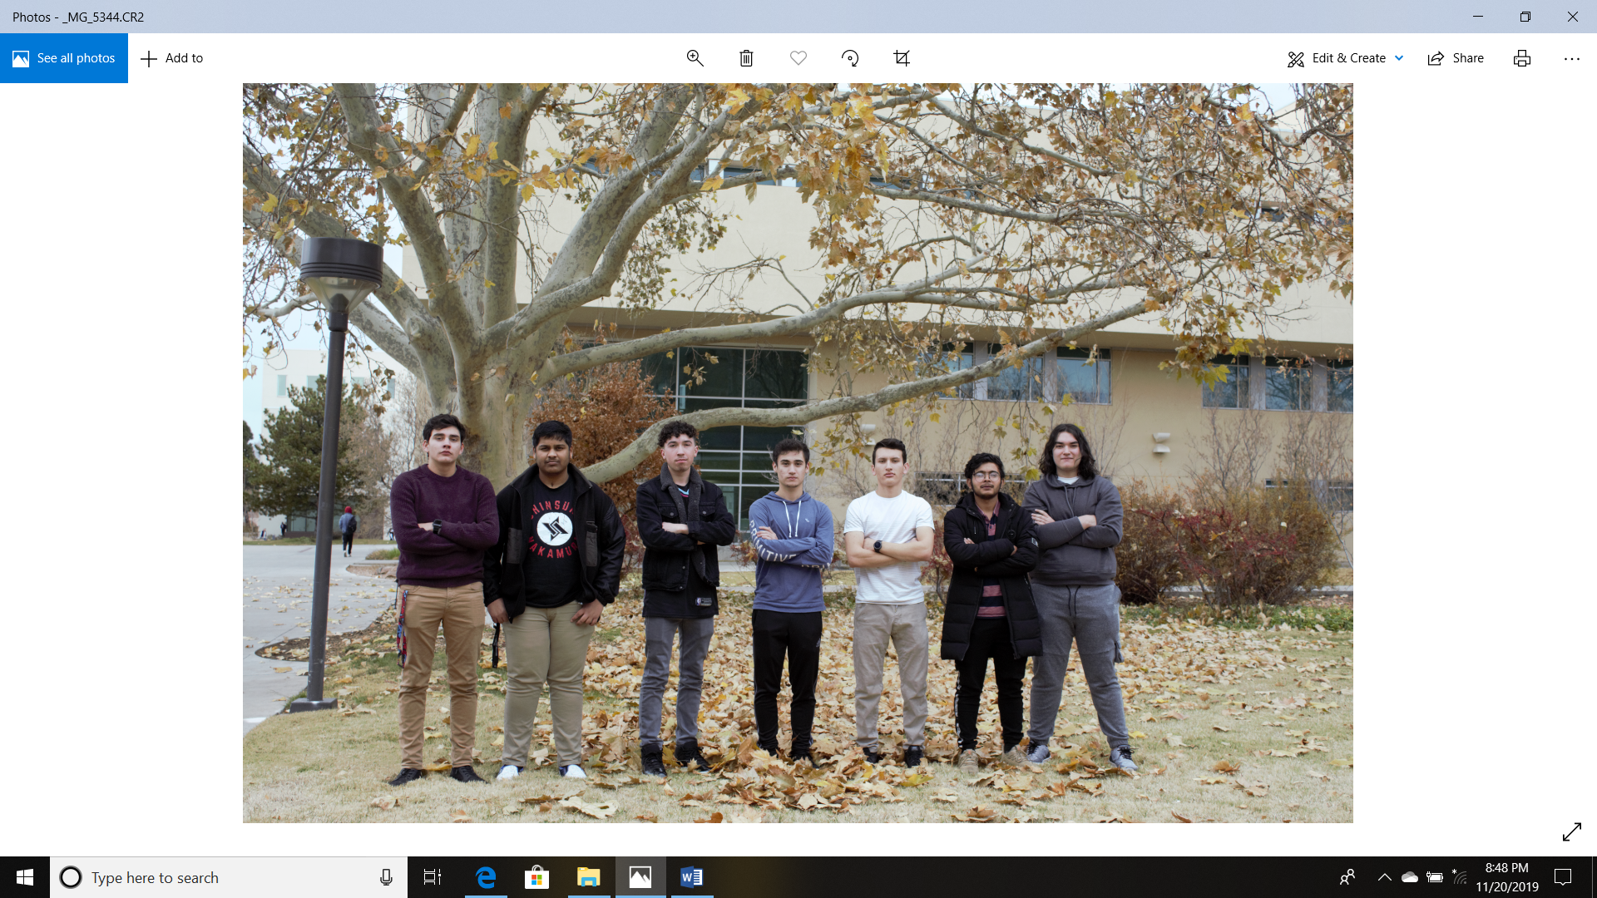

Figure 1: Pictured above, from left to right, Justice Otto, Anjan PN, Erik Morton, Jesse Garcia, Cameron Thomas, Bishwanath Bastola, Fabian Ortega

Dr. Matthias Pleil

Rahul Adhikari

Fall 2019

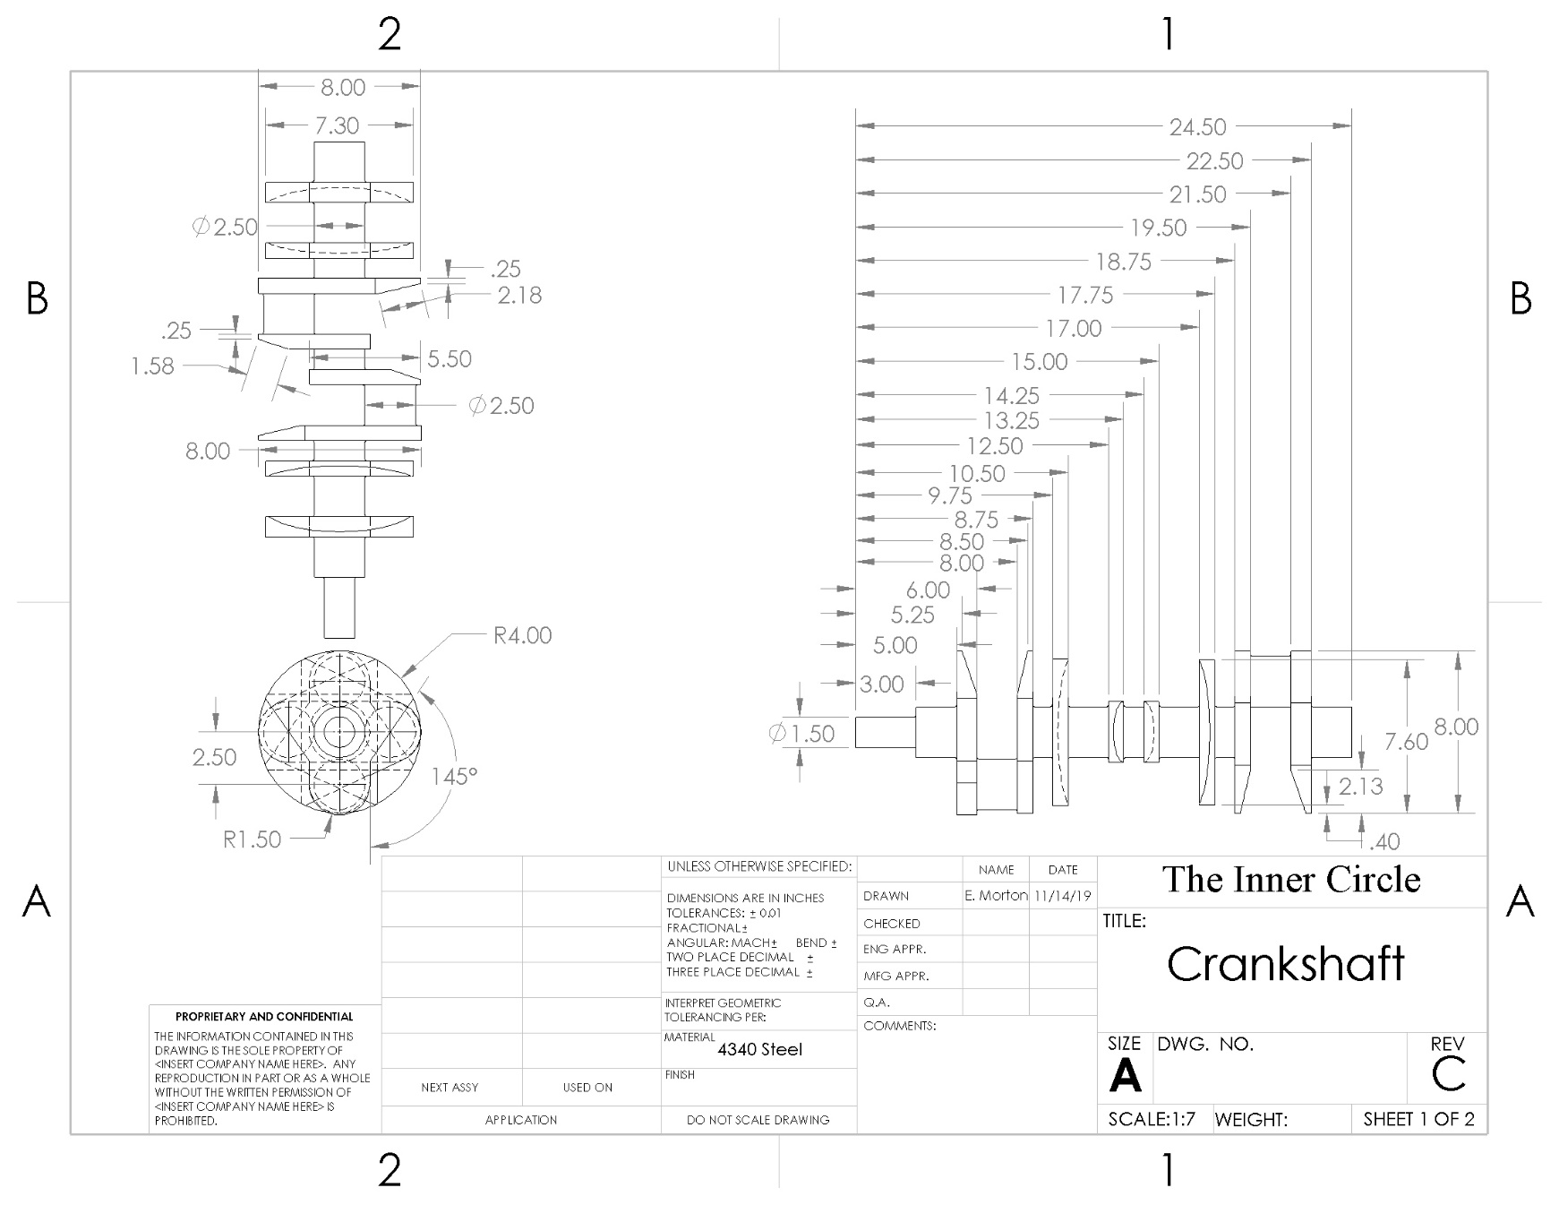

Figure : Crankshaft

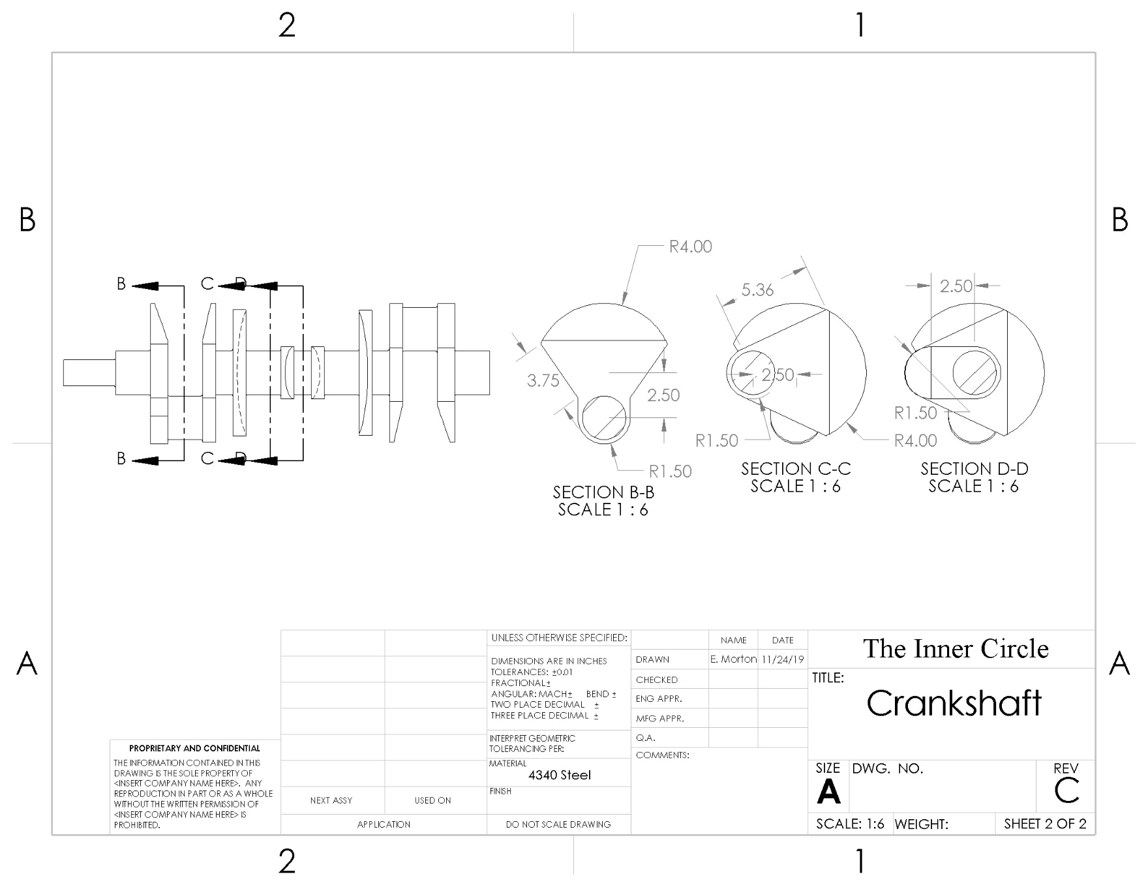

Figure : Sectional views of Crankshaft

Figure 4: Connecting Rod

Figure 5: Connecting Rod Cap

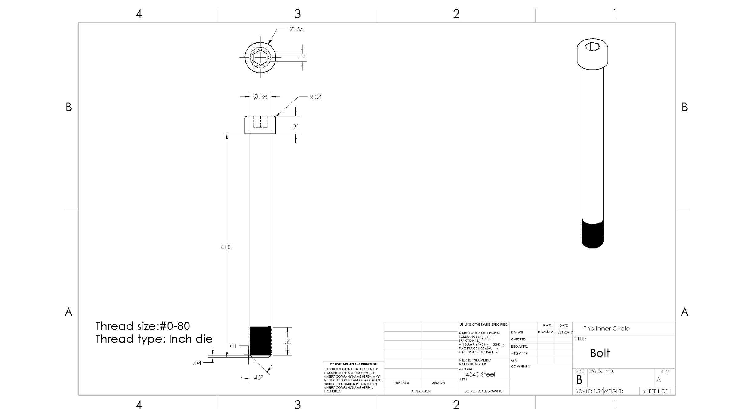

Figure 6: Connecting Rod Bolt

Figure 7: Connecting Rod Nut

Figure : Piston

Figure 9: Piston Pin

Figure : Engine Block Front View

Figure : Engine Block Rear View

Figure : Engine Block Top View

Figure : Engine Block Bottom View

Figure : Main Cap 1in Width

Figure : Main Caps 2in Width